

Architecture Design

Heart Disease Analysis

## 

1. **Introduction**

## What is Architecture Design Document?

Any software needs the architectural design to represent the design of the software. IEEE defines architectural design as “the process of defining a collection of hardware and software components and their interfaces to establish the framework for the development of a computer system.” The software that is built for computer-based systems can exhibit one of these many architectures. Each style will describe a system category that consists of

* + - A set of components (eg: a database, computational modules) that will perform a function required by the system.
    - The set of connectors will help in coordination, communication, and cooperation between the components.
    - Conditions that how components can be integrated to form the system.
    - Semantic models help the designer to understand the overall properties of the system.

## What is Scope?

Architecture Design Document (ADD) is an architectural design process that follows a step-by-step refinement process. The process can be used for designingdata structures, required software architecture, source code and ultimately, performance algorithms. Overall, the design principles may be defined during requirement analysis and then refined during architectural design work.

1. 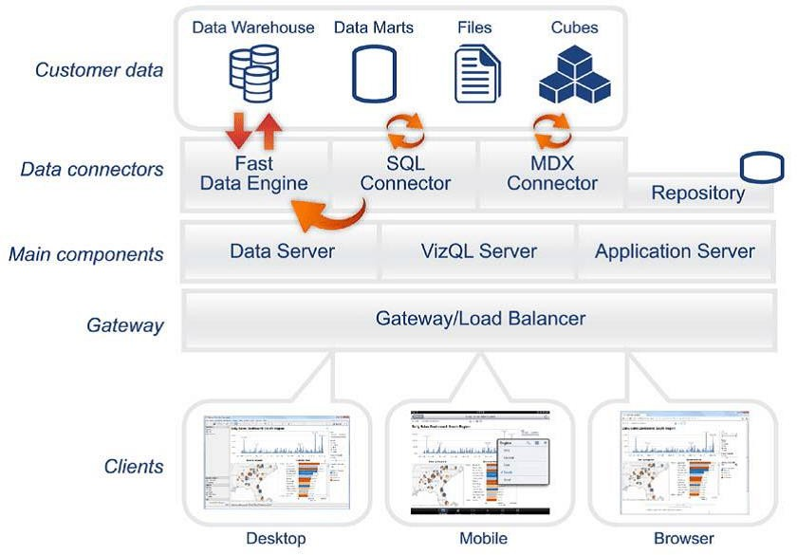**Architecture**

Power Bi architecture

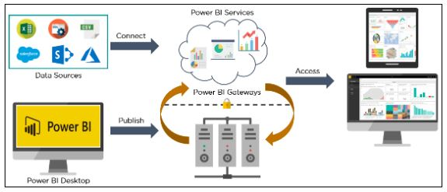

Power BI architecture is a service built on top of Azure. There are multiple data sources that Power BI can connect to. Power BI Desktop allows you to create reports and data visualizations on the dataset. Power BI gateway is connected to on-premise data sources to get continuous data for reporting and analytics. Power BI services refer to the cloud services that are used to publish Power BI reports and data visualizations. Using Power BI mobile apps, you can stay connected to their data from anywhere. Power BI apps are available for Windows, iOS, and Android platforms.

1. **Deployment**

## Deployment Options

The deployment process lets you clone content from one stage in the pipeline to another, typically from development to test, and from test to production.

Tableau’s analytics platform offers three different deployment options

depending on your environment and needs. The below graphic shows each option at a glance

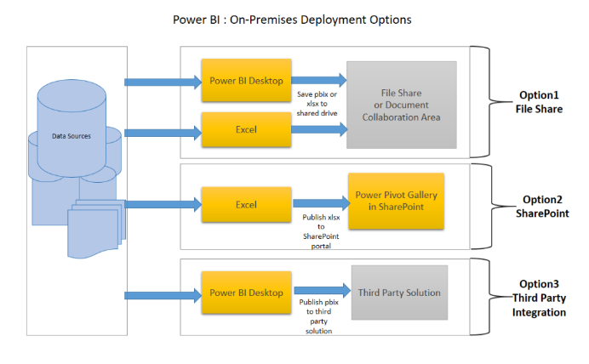****Option 1: Power BI Service****

* Data is either from the on premises corporate applications or it might be born in cloud. It can even mix of these two
* Data preparation and report creation occurs in Power BI Desktop or excel
* Completed Power BI reports are then published to Power BI service
* Report consumption, sharing, security, collaboration, data refresh happens in Power BI service
* Dashboards are created in Power BI service and reports can also be edited or created in Power BI service

****Option 2: Custom Application Integration****

* Data is either from the on premises corporate applications or it might be born in cloud. It can even mix of these two
* Data preparation and report creation occurs in Power BI Desktop or excel
* Completed Power BI reports are then published to Power BI service
* With Power BI API , these reports can be published in custom web application or mobile app  within iFrame
* If user interacts with this report, he/she will be redirected to Power BI service
* Application can be on premise or cloud application

****Option 3: Public Website****

* Data is either from the on premises corporate applications or it might be born in cloud. It can even mix of these two
* Data preparation and report creation occurs in Power BI Desktop
* Completed Power BI reports are then published to Power BI service
* An embed code is generated by Power BI service for selected report and this code can be embedded in web page of the website within iFrame
* Here no security is maintained as its public website, hence suitable for the data which can be made publicly available

Single Node Architecture

This architecture is a single node architecture. This is the simplest deployment topology. This type of installation is reasonable for testing, running trials, and for environmentsthat can handle occasional downtime and system availability due to lack of redundancy. All server processes are running on a single machine. There is less redundancy and fewersafeguards in the event of a problem with one of the server processes. You also need to make sure the computer you install Tableau Server on has adequate resources to handle the processes and the demands of users and data.

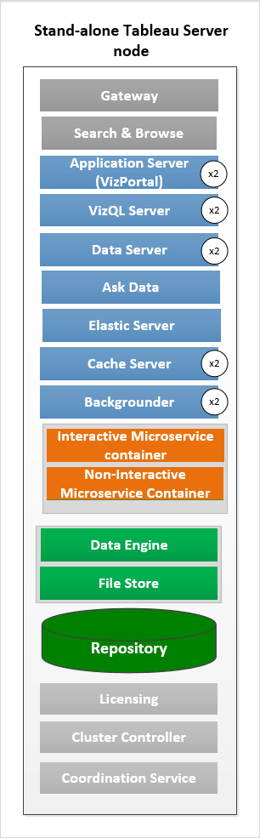

## Two Node Architecture

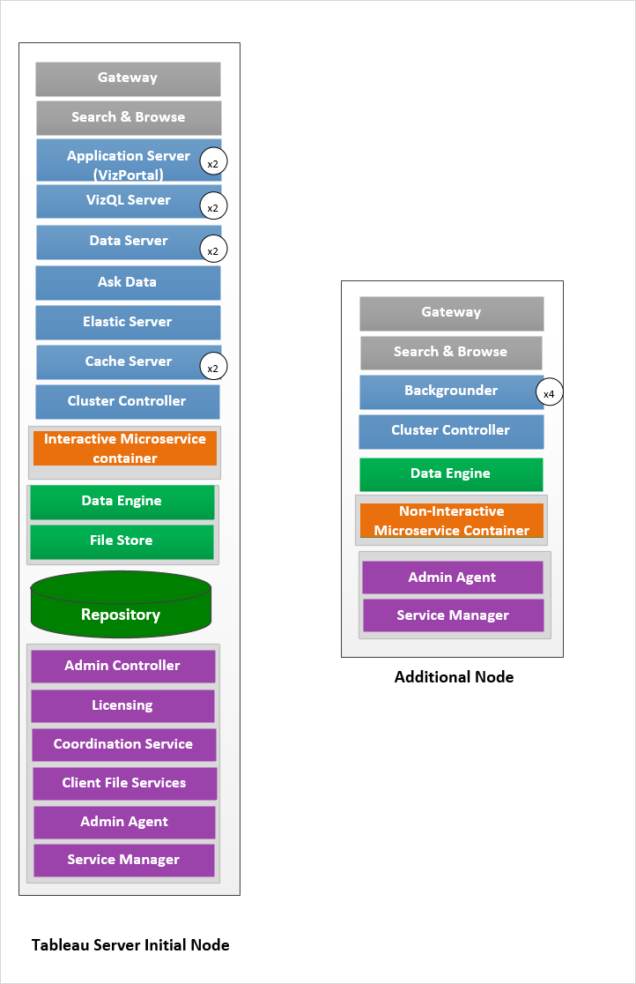

If we need failover or high availability or want a second instance of the repository,

install Tableau Server on a cluster of at least three computers. In a cluster that includes at leastthree nodes, you can configure two instances of the repository, which gives our cluster failovercapability.

* Extract heavy environment
* Frequent extract refreshes

## Five Node Architecture ( Highly Available)

An HA installation of Tableau Server is a special type of multi-node installation with a minimum of three nodes and multiple instances of key processes (the Repository, FileStore/Data Engine (Hyper), Coordination Service, and Client File Service) on different computers. With an HA installation, there is built-in redundancy of those key

processes, including multiple File Stores, and automatic Repository failover. The goal is to minimizesystem downtime by eliminating single points of failure and enabling detection of failureswith failover where possible.

Downtime is still possible, in the event of an initial node failure. Dashboards and views may load more slowly than expected, and timeouts are possible, depending on how your the system isconfigured and being used.

